

The University of Hong Kong

Faculty of Engineering

Department of Computer Science

ICOM6034 Website Engineering

Individual Report

By

Kwan Ho Tin, Joseph (UID: 3035751828)

Date:25/4/2021

**List of works done:**

1. Profile Read and Update

2. NewsAPI API integration

3. Task management add-on function with google map api

4. Task details module with stock API and google map api

5. Dashboard module

6. other enhancements and modification with Jack

Commit logs: https://github.com/josephKwan/laradmin/commits/main

1. Profile Read and Update

**High-level system design**

Description:

The module is to provide a read function to review their profile with a modal and update their username and email.

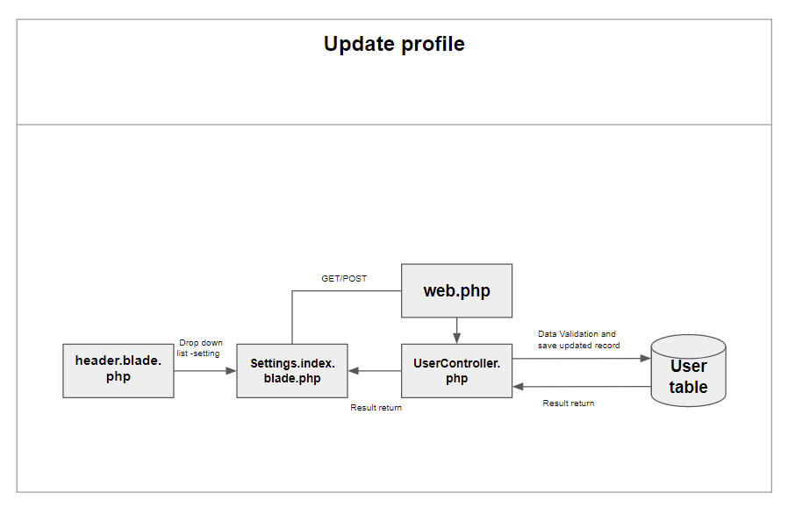

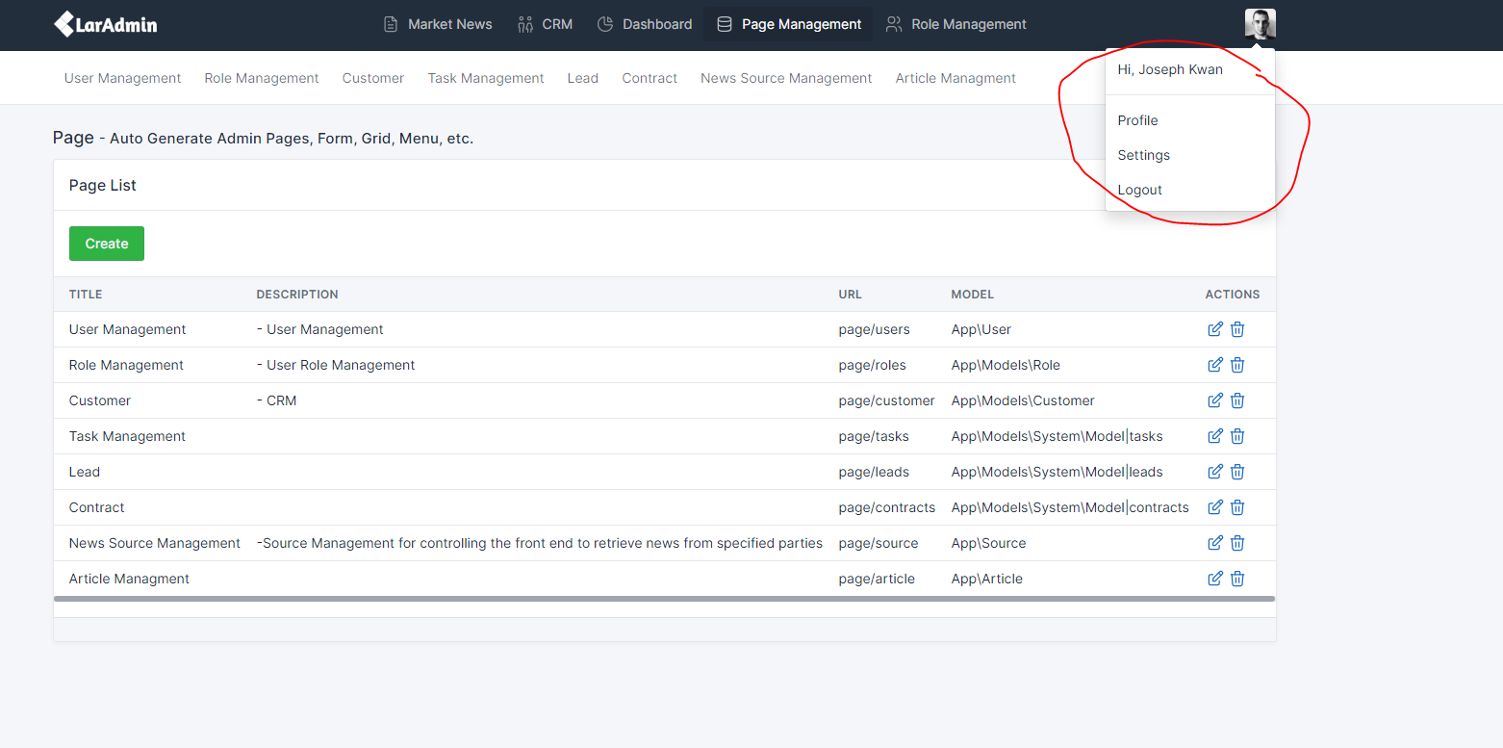

* + 1. Review own profile with a modal by using Laravel auth function.

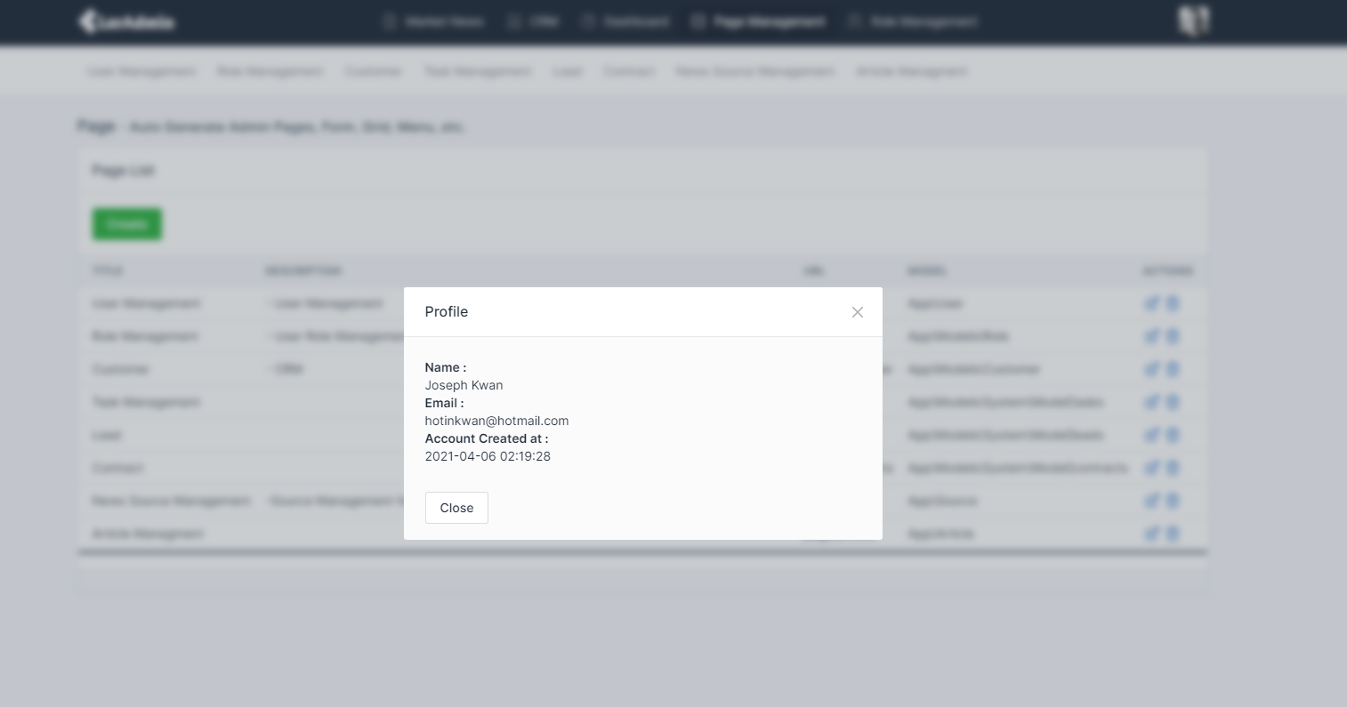

* + 1. Update the own profile with data validation

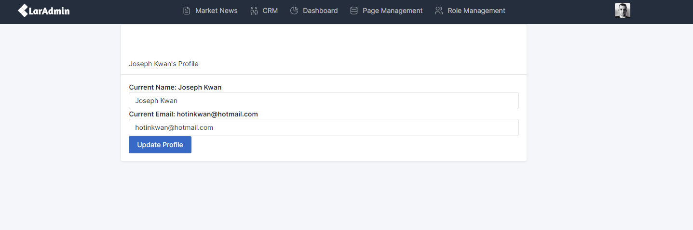

iii. validation error list

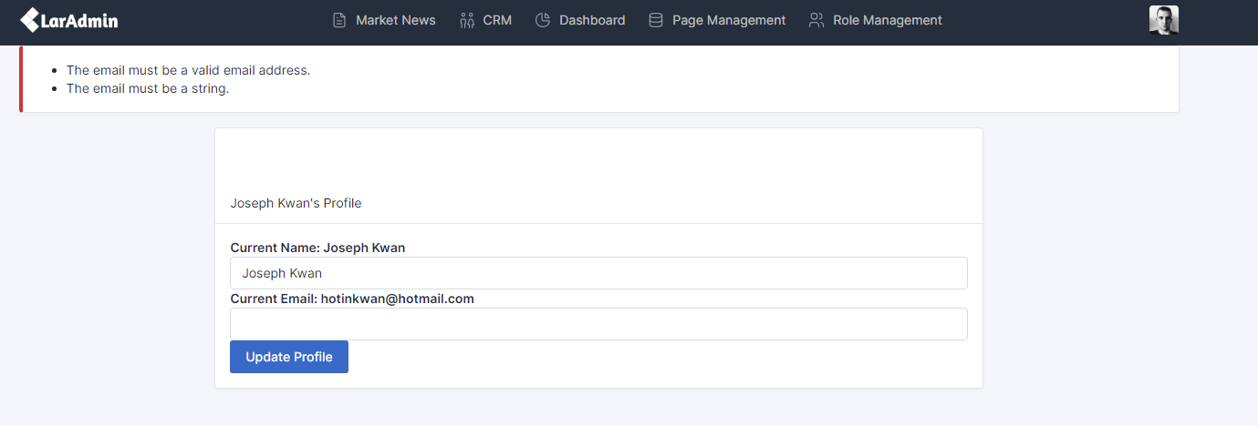

iv. Change the name from Joseph Kwan to Joseph

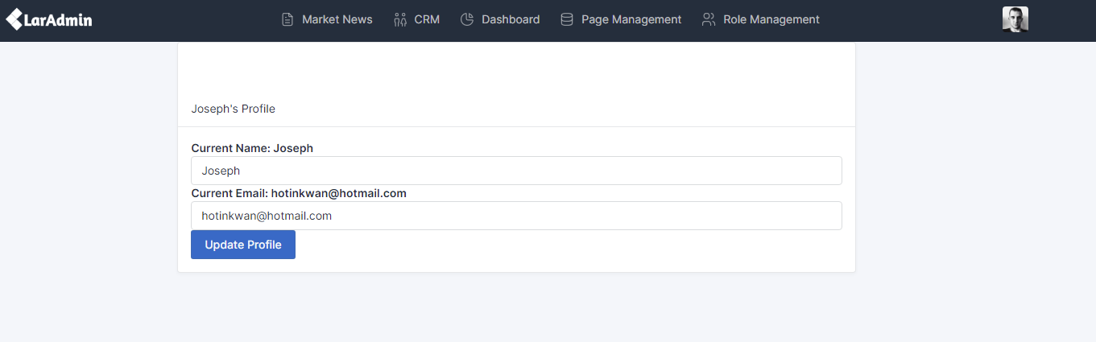

2. NewsAPI API integration

Description:

To make the index page more dynamic, news api is used specifically for the CRM users to explore more business opportunities.

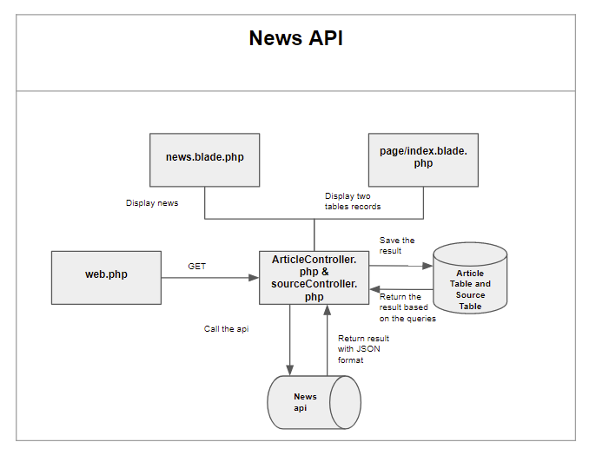

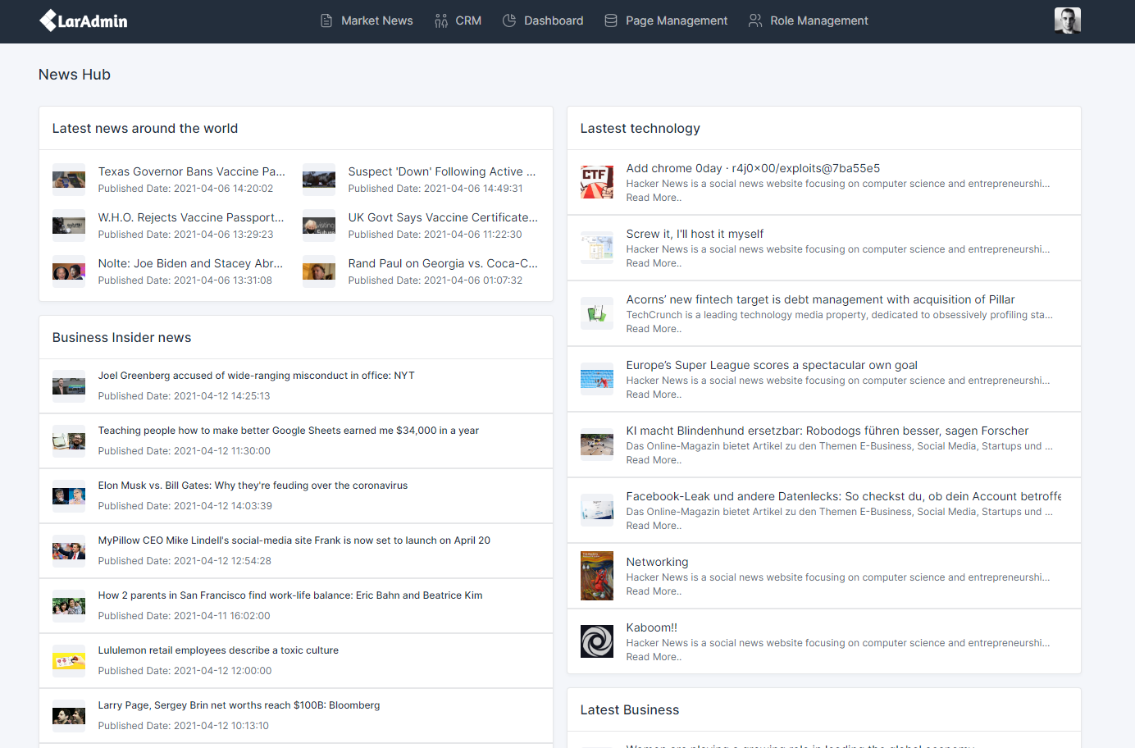

1. Set up the route to the source controller and disable it as a backup
2. get a list of sources and input to the source table from the news API to setup the backbone
   1. Sources including but not limited to
      1. Bloomberg
      2. Business insider
3. Create a source management page in the page management as to manipulate the source going forward

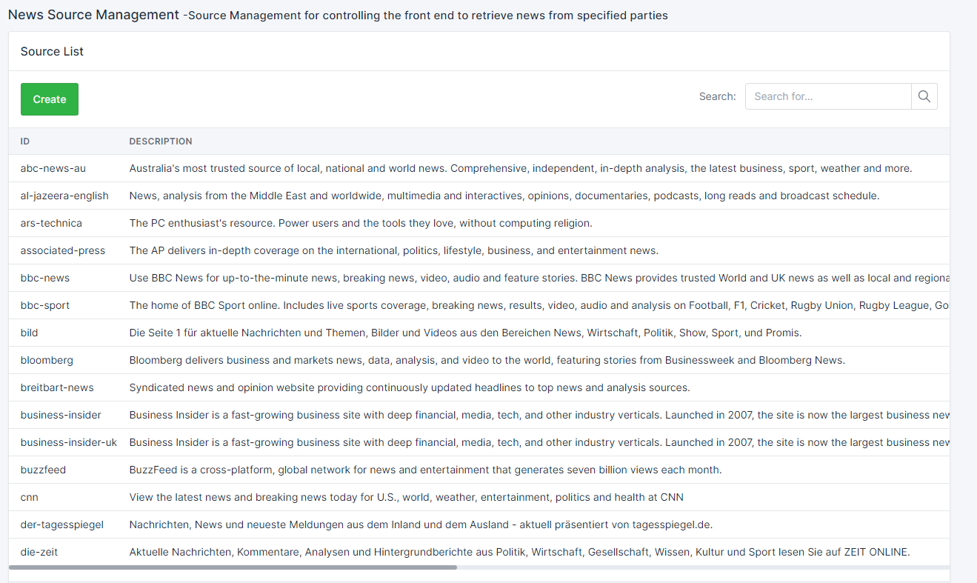

1. Add Route::get(‘/’, ArticleController@index’) to the web.php.
2. ArticleController gets the news based on the random source via the api and decode json the save to the article table
3. Set up different sql to display different news
   1. Display the news from source business-insider -uk
   2. Display the news from the source in which the category is technology
   3. Display the news from the source in which the category is business
   4. Display the news from the single random source
4. Create the article management page that could control the frontend articles and include the search function by “Source”

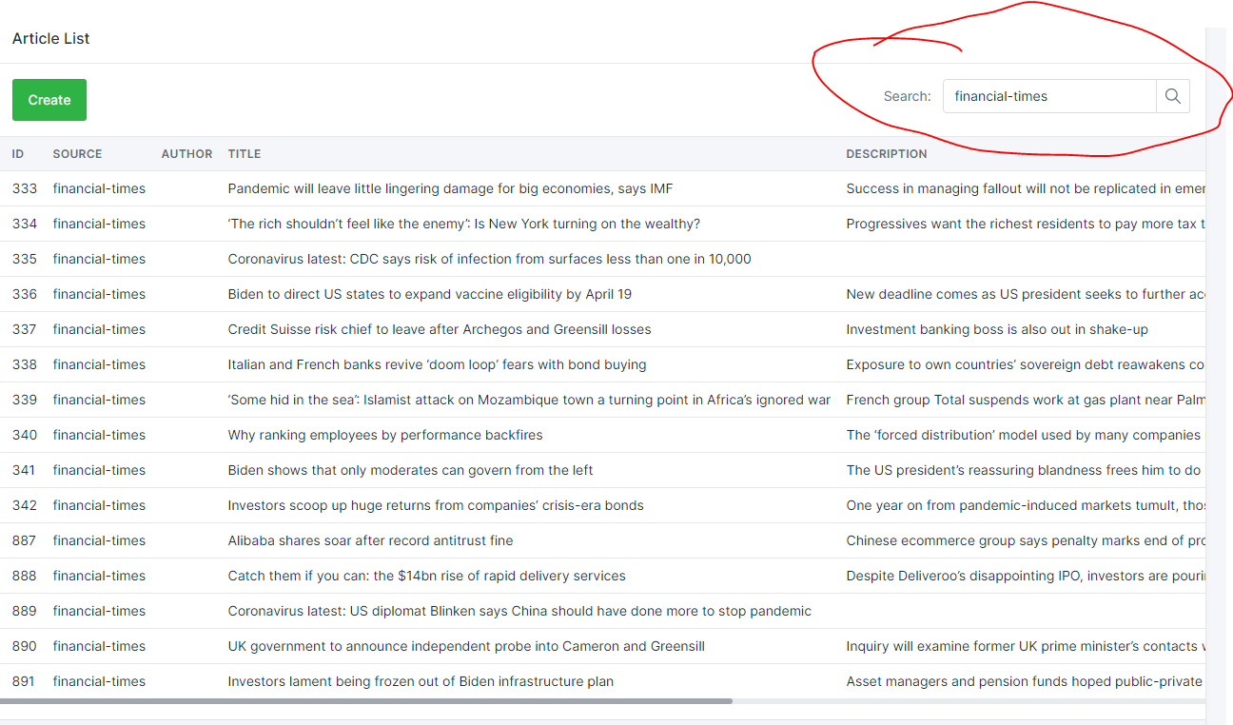

3. Task management add-on function with google map api

Description:

To display the real location for the user, google map api is integrated with the Task management page.

* 1. Modify the table.blade.php under the widgets
     1. Check if pages include a column called location
  2. If a column location found, a modal function would be embedded

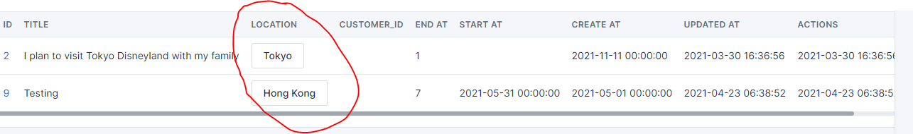

* 1. Include the row id for the modal ID so that a modal could be created multiple times with different content4.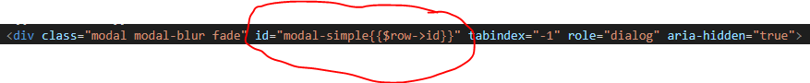
  2. Call the google map api
  3. Query the map based on the location. Examples as below
     1. Tokyo

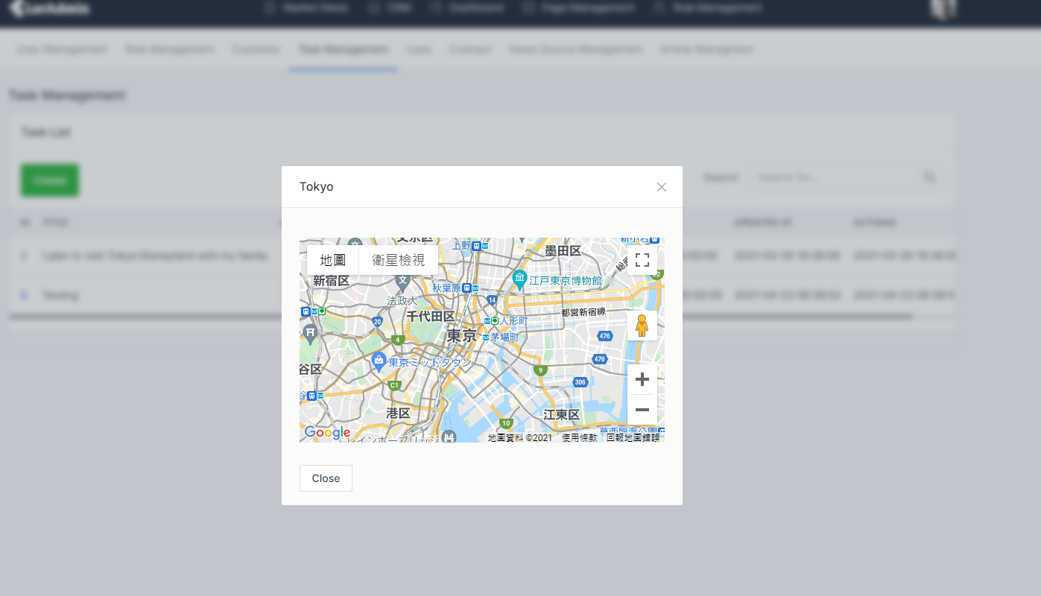

* + 1. Hong Kong

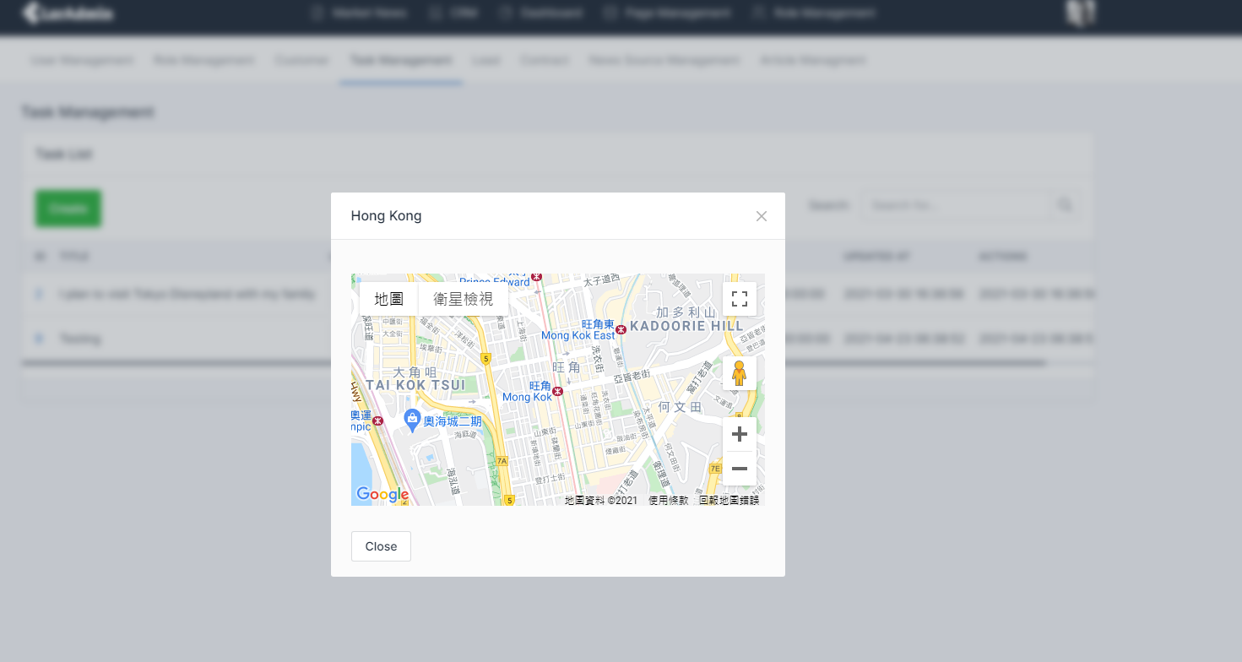

4. Task details module with stock API and google map api

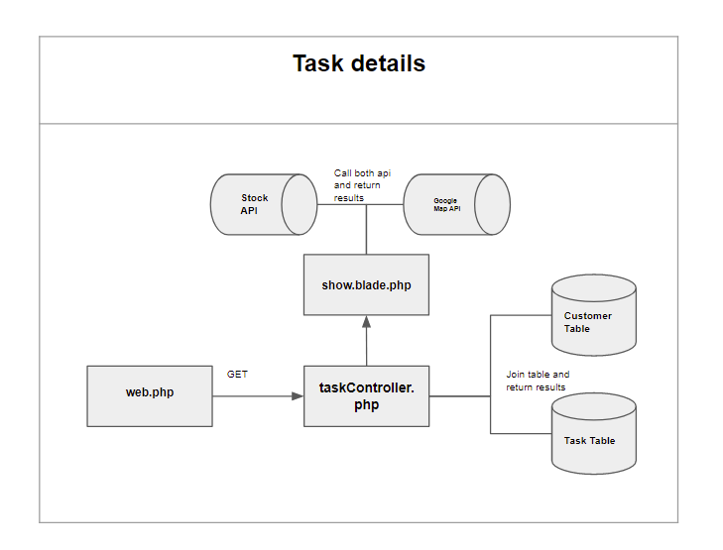

Description:

To show the relationship with the customer details for the task management, further details could be reviewed by the add on module.

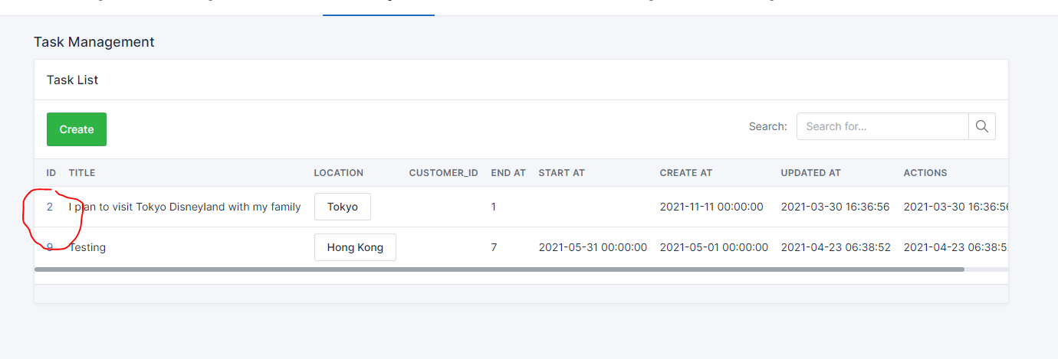

1. Set up a route with the task id parameter for the url Route::get('/tasks/show/{id}', 'taskController@show');
2. Set up the task controller
   1. Join the table between tasks and customers based on the task id
3. Set up the view to show the details of the task and customer related to this task

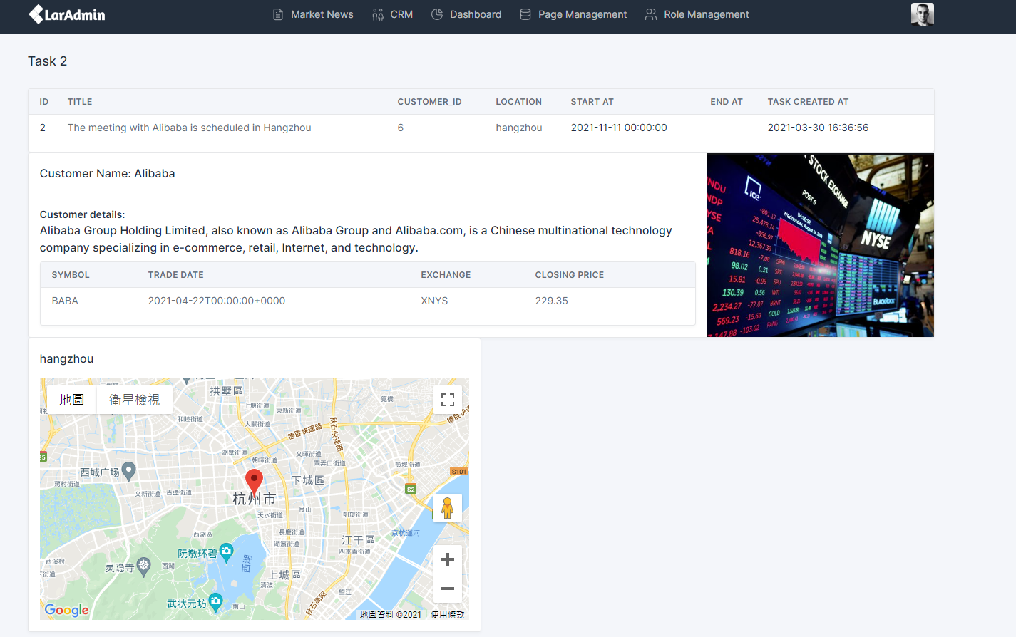

1. Include the task details for the first part of the page by retrieving from the task table
2. Include the customer details in the middle of the page by calling the api to Stock Api with jquery and ajax and retrieving details from customers table
   1. For example, the task title is “the meeting with Alibaba is scheduled in Hangzhou”. The customer is Alibaba
   2. The details of the Alibaba will be retrieved from the customer table
   3. The api will start calling with the symbol provided in the customer table to get the latest trade date, the equity where it listed and the end of date stock price.
3. Include the location with the google map
   1. Querying the google map with the task location

5. Dashboard module

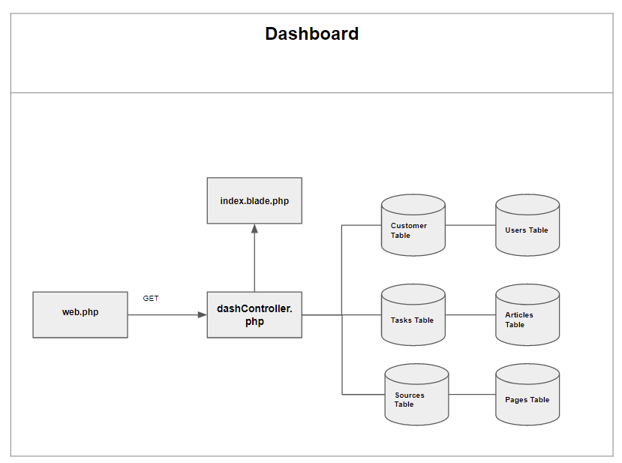

Description:

To visualize the data and to gather the information of the website, a report page is created for the administrator.

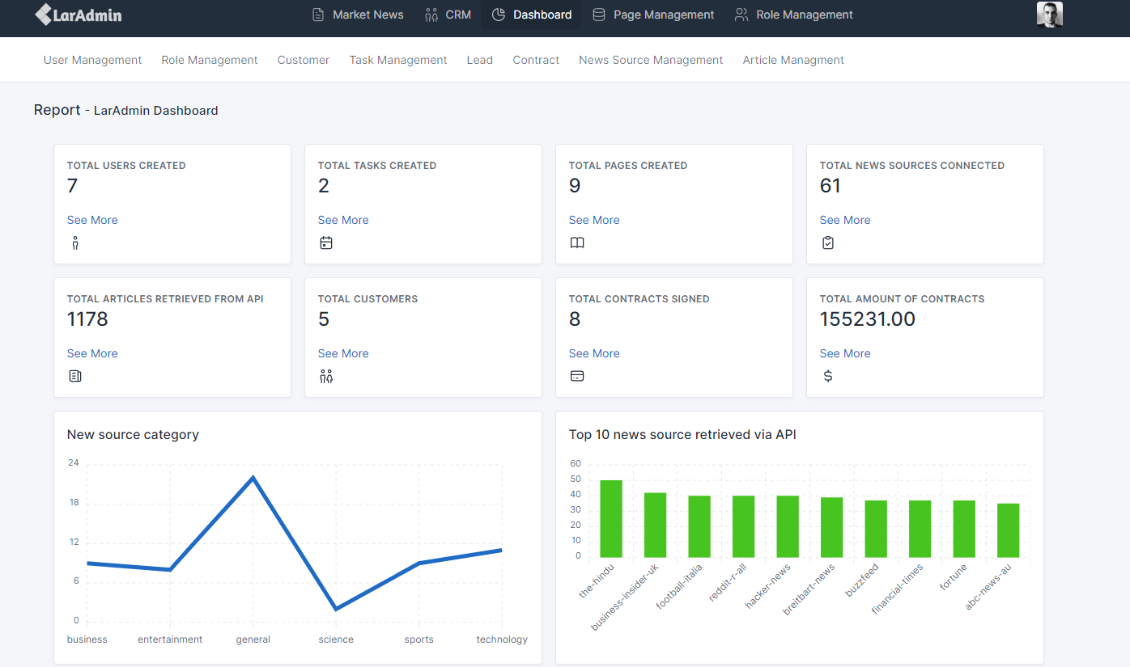

1. Set up resource in web.php

2. Create dashboard controller for interfacing with the database. Examples as below

* Sum up the total contract amount
* Count pages

3. Create the view for the data queried from the various tables

4. Utilise the apex chart to create a line chart and a bar char with the data in Json format